

WARREN HAYNES
Officially Reveals Details for New Solo Album
Million Voices Whisper
Out November 1st on Fantasy Records

Releases New Single “This Life As We Know It”
PRESS HERE To Listen
PRESS HERE To Watch Studio Video

Album Pre-Order Available Now

Million Voices Whisper Tour
Launches September 19th
Tickets On Sale Now

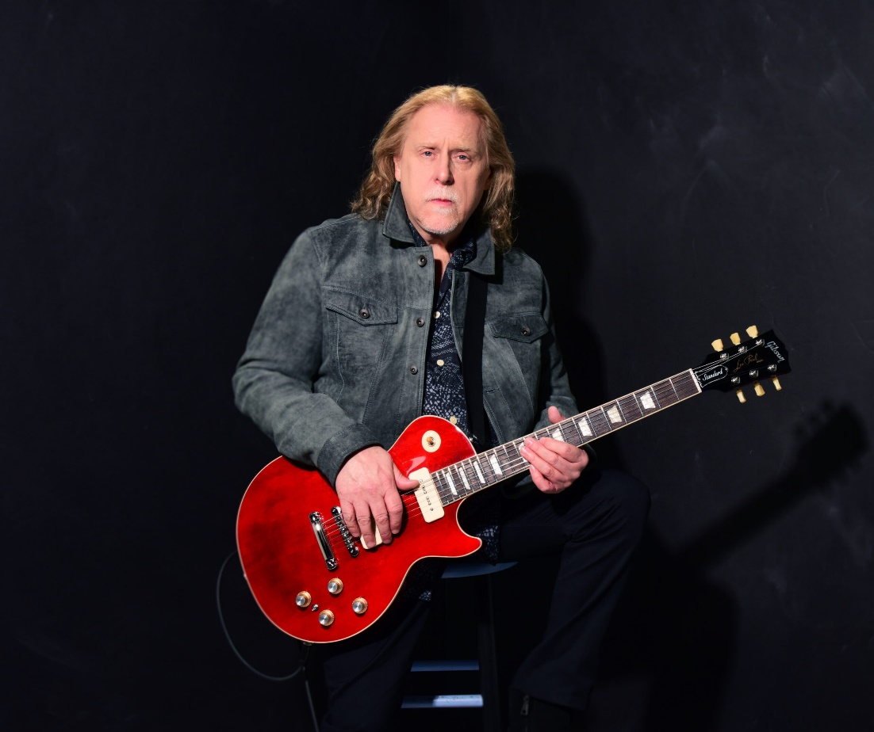
Photo credit: Shervin Lainez

"Warren Haynes is a meaty and masterful player, as well as a soulful singer and songwriter
– an all-star." – Rolling Stone

“[Warren Haynes is] one of the most celebrated, legendary guitar pros.” – Billboard

“Warren Haynes is one of the greatest practitioners of rock and roll in the history of the artform.”
– Salon

“One of his generation’s best and most important guitarists.” – Guitar World

“[Warren Haynes’] voice, guitar and songs recall the blues and rock of the late ‘60s and ‘70s, yet he presents it all with a modern punch that makes even the most classic tropes and progressions sound contemporary. He's a treasure.” – Ultimate Classic Rock

“With each album, Warren Haynes takes one giant leap forward in sealing his legacy as one of the most versatile singers, songwriters, guitarists and producers of the last 30 years.”
– Vintage Rock

FOR IMMEDIATE RELEASE – August 29, 2024 – GRAMMY® Award-winning vocalist, songwriter, guitar legend, producer, and Gov’t Mule front man Warren Haynes has officially revealed the details for his new solo album, Million Voices Whisper, and has shared the first single “This Life As We Know It.” The new song is Warren’s universal message for embracing the positivity of change and looking forward through a new lens – one that starts within. PRESS HERE to listen and PRESS HERE to watch the in-studio performance video featuring behind-the-scenes content from the recording of “This Life As We Know It” at Power Station New England. Million Voices Whisper, produced by Haynes, will be released November 1st digitally and on CD via Fantasy Records, with vinyl shipping on November 15th, marking Warren’s first solo album in almost a decade. A deluxe CD version will also be available including four bonus songs. PRESS HERE to pre-save and pre-order.

“It felt great to go into the studio to capture this material with this new band who are all fantastic players,” shares Haynes. “This album is quite different than my previous solo records. There's a lot of soul music influence but very song oriented with subtle nods to a few of my heroes. And what a treat to get back into the studio with my brother Derek. Big shoutout to him as well as Lukas and Jamey for being a part of it. I'm really proud of this new album.”

Of “This Life As We Know It,” he adds, “It has a very uplifting message and musically, as well, it is just a very positive feeling song. One that I feel we can all relate to. It’s about moving forward and getting past a lot of things but feeling good about life and feeling good about yourself.”

On Million Voices Whisper, the fourth solo album in Warren’s esteemed career catalog, Haynes sounds as energetic and focused as ever, powering through an 11-song set of soulful blues-rock. Accompanying Warren on the collection are members of his current all-star band including John Medeski on keyboards, longtime drummer Terence Higgins (of the Dirty Dozen Brass Band) and Gov’t Mule bassist Kevin Scott. Million Voices Whisper also features guest appearances from his Allman Brothers Band compatriot Derek Trucks, whose unmistakable guitar sound toughs up three tracks on the album that were co-produced with Haynes, and his Last Waltz Tour co-stars Lukas Nelson and Jamey Johnson, who are featured on the forceful “Day of Reckoning.” Joining Haynes in the studio for the first time since the final sunset of the ABB, one of the featured tracks with Trucks on guitar is “Real Real Love,” a song initially co-written with Gregg Allman that Warren finished in Allman’s style and methods as if Gregg were singing it to honor his friend.

Buzzing through the forthcoming album is the question of how to make things better – in love, in life, in the world – led by Haynes’ soaring vocals and the poignancy of his six-string mastery. Million Voices Whisper opens with "These Changes," a co-write with Trucks, leading into “Go Down Swinging,” co-written with Johnson, which features a horn section and a Van Morrison vibe. Then, there’s the soulful power ballad “Till The Sun Comes Shining Through” driven by Warren’s impassioned vocals and slide guitar skills. The expressive pipes of touring backup singer Saundra Williams are also heard on multiple tracks including the new single “This Life As We Know It.” Among the four bonus tracks on the deluxe CD version is a new version of the Trucks-Haynes composition “Back Where I Started” featuring Warren on lead vocals and slide guitar and the power trio of Haynes, Nelson and Johnson covering the CSNY classic “Find The Cost of Freedom” into an extended version of “Day of Reckoning.” Full track listing for Million Voices Whisper below.

Haynes and his band, including Greg Osby on sax, will support the release of Million Voices Whisper with a 16-date fall headlining tour. The Million Voices Whisper Tour kicks off September 19th and stops throughout the east coast before wrapping October 12th. Tickets and specially curated fan packages are available now. Following the band’s tour, Haynes will head to Los Angeles to perform at The Kia Forum on October 17th for the Robbie Robertson “Life Is A Carnival” celebration event. See below for full list of upcoming tour dates and visit www.warrenhaynes.net for more information and to purchase tickets.

Before launching their fall tour, Haynes will resume his Now Is The Time Tour featuring The Warren Haynes Band & The Dreams and Songs Symphonic Experience on September 10th with a special stop at Red Rocks Amphitheatre with the Colorado Symphony. Led by conductor Rich Daniels of Chicago’s City Lights Orchestra, the brand-new show features nearly three hours of music – two full symphonic sets with the orchestra followed by a full set showcasing Haynes’ signature rock/soul blend with just the WHB and background singers Saundra Williams and Mayteana Morales. The Now Is The Time Tour explores all aspects of Warren’s incredible catalog and career, including music from Gov’t Mule, Allman Brothers Band, The Dead, his solo albums, and more, set to new arrangements, and finds Haynes revisiting compositions from the groundbreaking Jerry Garcia Symphonic Celebration tour.

Million Voices Whisper is a set of powerful, soulful tracks that combine the eloquent musicianship of a triple-threat blues-rocker with the glowing spirit of a vital creative artist at the peak of his powers. It is Warren Haynes’s best album yet.

Million Voices Whisper Track Listing:
- These Changes (ft. Derek Trucks)
- Go Down Swinging
- You Ain’t Above Me
- This Life As We Know It
- Day of Reckoning (ft. Lukas Nelson and Jamey Johnson)
- Real, Real Love (ft. Derek Trucks)
- Lies, Lies, Lies > Monkey Dance > Lies, Lies, Lies
- From Here On Out
- Till The Sun Comes Shining Through
- Terrified
- Hall of Future Saints (ft. Derek Trucks)

Deluxe Edition (CD only) bonus tracks:
- Baby’s On The Move
- Smooth Sailing
- Find The Cost of Freedom > Day of Reckoning [extended version] (ft. Lukas Nelson and Jamey Johnson)
- Back Where I Started (ft. Derek Trucks)
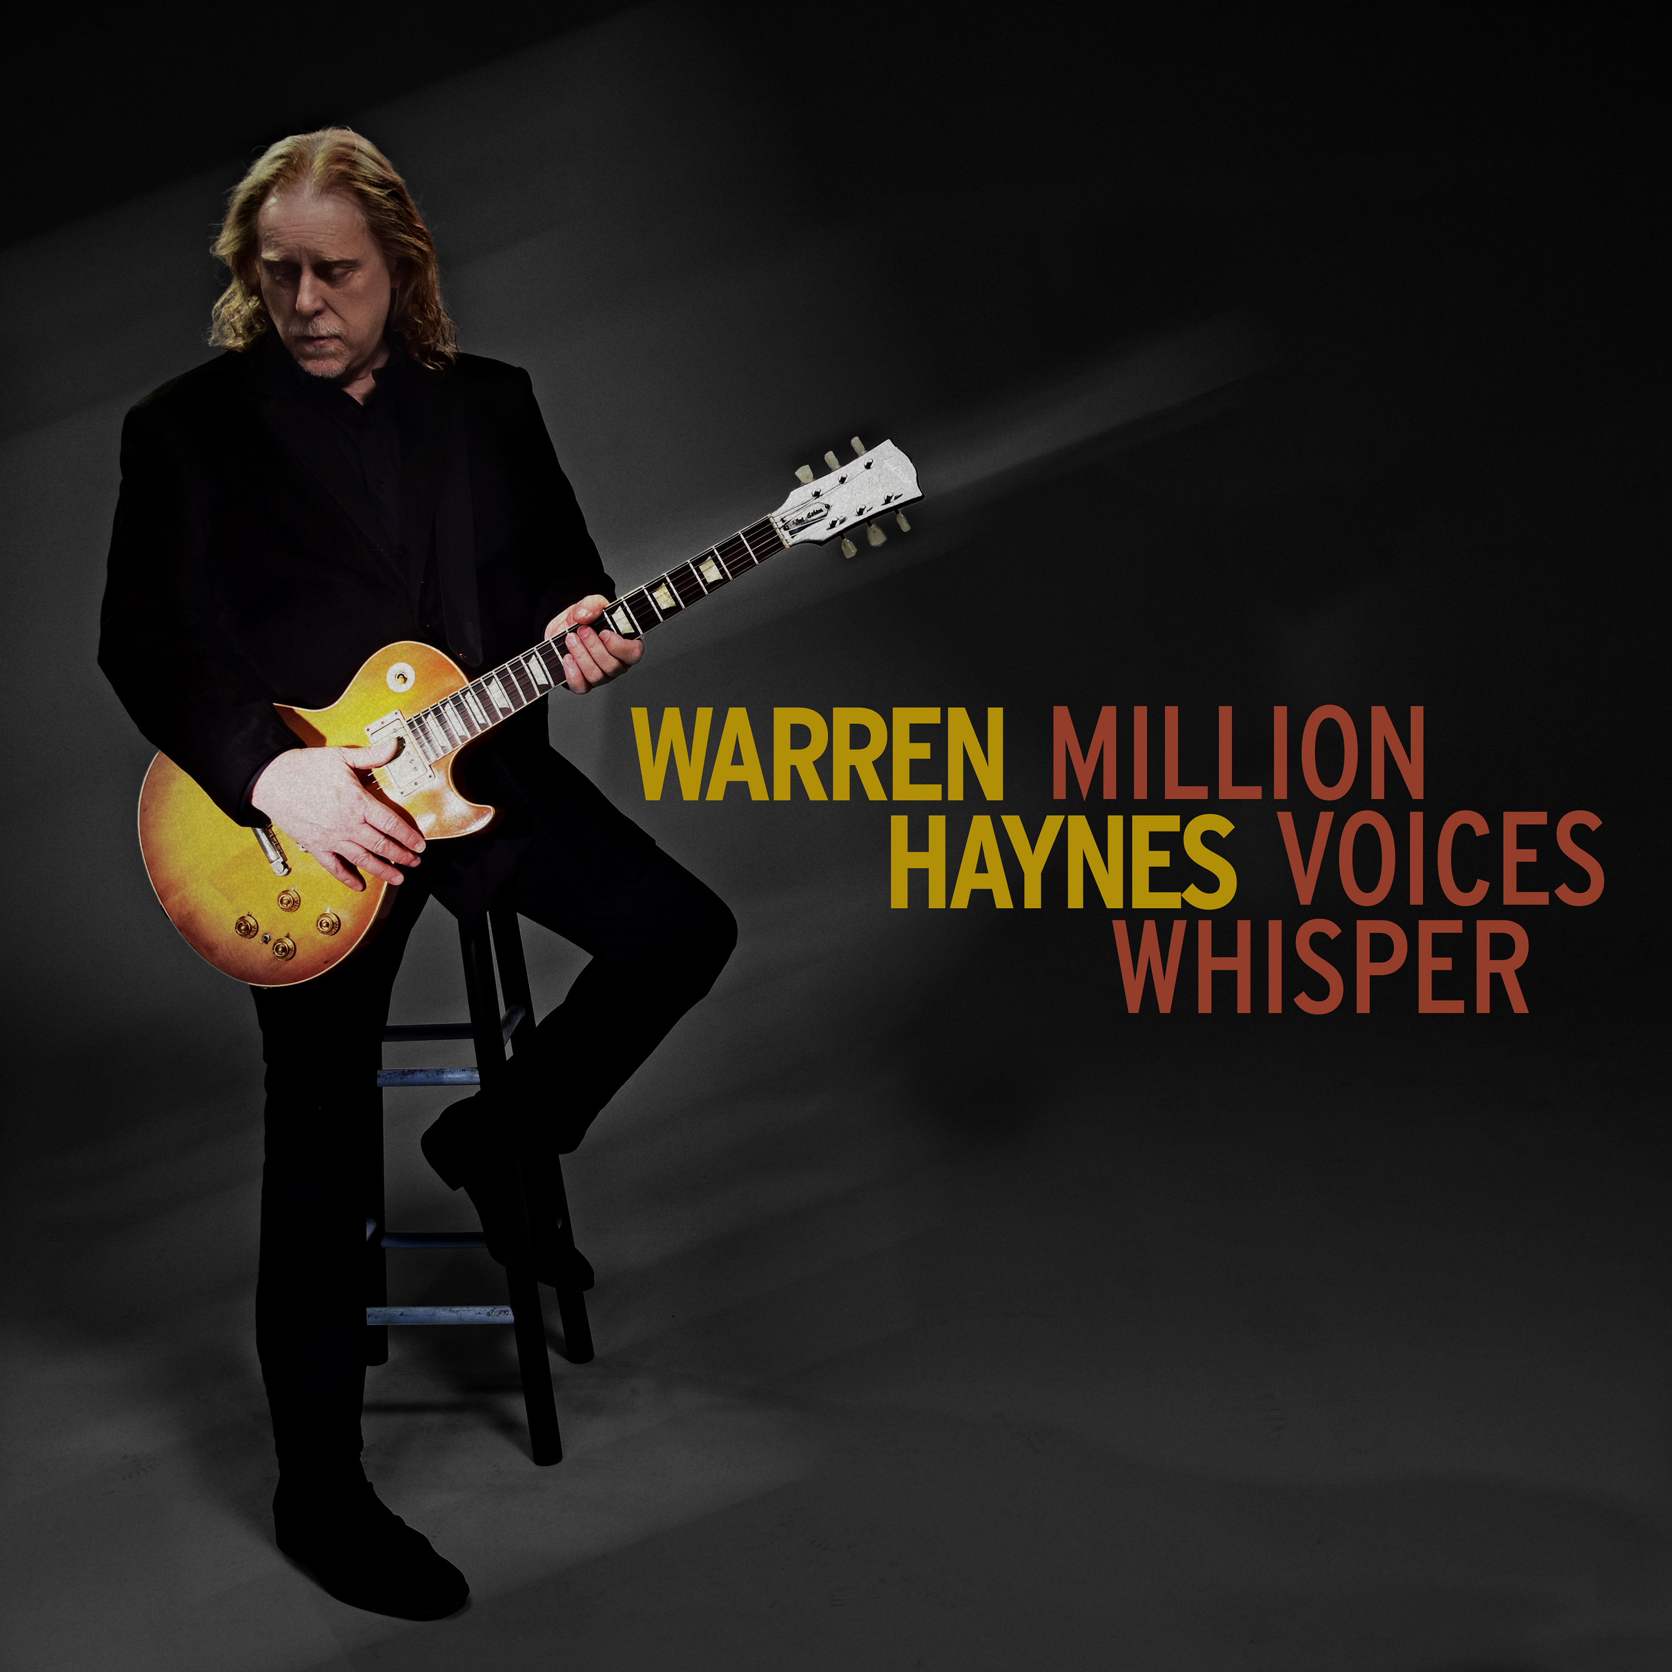
(Million Voices Whisper cover art)

WARREN HAYNES TOUR DATES
Now Is The Time Tour featuring The Warren Haynes Band & The Dreams and Songs Symphonic Experience
September 10 – Morrison, CO @ Red Rocks Amphitheatre

Million Voices Whisper Tour featuring The Warren Haynes Band
September 14 – Fredericton, NB @ Harvest Music Festival
September 19 – Fort Lauderdale, FL @ The Parker
September 20 – Fort Myers, FL @ Barbara B. Mann Performing Arts Hall
September 21 – Jacksonville, FL @ Florida Theatre
September 22 – St. Petersburg, FL @ Mahaffey Theater
September 24 – Pensacola, FL @ Saenger Theater
September 26 – Richmond, VA @ The National
September 27 – Norfolk, VA @ The NorVa
September 28 – Columbia, SC @ Township Auditorium
September 29 – Salem, VA @ Salem Civic Center
October 3 – Washington, DC @ Warner Theatre
October 4 – Ashland, KY @ Paramount Arts Center
October 5 – Memphis, TN @ Mempho Music Festival (early set)
October 5 – Nashville, TN @ Ryman Auditorium
October 9 – Philadelphia, PA @ The Fillmore Philadelphia
October 10 – Syracuse, NY @ The Oncenter Crouse Hinds Theater
October 11 – Port Chester, NY @ The Capitol Theatre
October 12 – Boston, MA @ Orpheum Theatre

Life Is A Carnival: A Musical Celebration of Robbie Robertson
October 17 – Los Angeles, CA @ Kia Forum

Island Exodus 15
Featuring Gov’t Mule, Warren Haynes, Drive-By Truckers, Karina Rykman & Big Sugar
January 19-23, 2025 – Runaway Bay, Jamaica @ Jewel Paradise Cove Resort

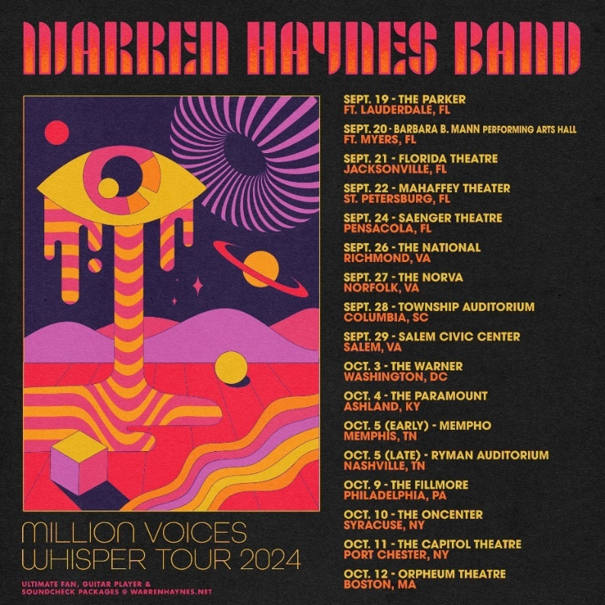

ABOUT WARREN HAYNES
Visionary GRAMMY Award-winning artist Warren Haynes is a cornerstone of the American music landscape, lauded as one of the most formidable guitarists and vocalists of the modern era and a prolific songwriter and producer. He effortlessly cross-pollinates genres and unfurls solos that broil with passion in his distinctive, signature style. Throughout his prolific career as part of three of the greatest live groups in rock history – Allman Brothers Band, Gov’t Mule and the Dead – and an acclaimed solo artist, he has become one of music’s most treasured storytellers and his artistry has led to thousands of memorable performances and millions of album and track sales. Haynes is a beacon of creativity and musical excellence that inspires fans as well as fellow musicians, evidenced by the diverse array of artists that he has performed and recorded with, including Dave Matthews Band, Peter Frampton, Chris Stapleton, Coheed and Cambria, Dave Grohl, Carlos Santana, Willie Nelson, and Dolly Parton, and many more. After joining the Allman Brothers Band in 1989, Haynes released his first solo album, Tales of Ordinary Madness, in 1993 and soon after, he formed Gov’t Mule originally as a side project during band breaks. The Mule has since created a revered catalog over the past 30 years, including multiple Grammy nominations, leading them to be recognized as one of the most timeless, respected and active bands in the world whose spot amongst rock titans remains unshakable. Following a handful of solo live releases in 2003 and 2004, Haynes released his Grammy-nominated sophomore solo album, Man In Motion, in 2011 and then his third solo collection, Ashes & Dust, in 2015. Haynes also curates and hosts the Christmas Jam, an annual star-studded holiday charity show in his hometown of Asheville, North Carolina, which celebrates its 33rd event in 2024. As one of the most celebrated and longest-running live concerts in the U.S., the Christmas Jam has raised nearly $3 million for Asheville Area Habitat for Humanity, constructing over 50 homes, and helps the region’s housing needs through newer partner BeLoved Asheville.

FOLLOW WARREN HAYNES:
www.warrenhaynes.net
Facebook | Instagram | X/Twitter
YouTube | Spotify | Apple Music

For more information on Warren Haynes, please contact:
Press Here
Bari Lieberman / bari@pressherepublicity.com
Linda Carbone / linda@presshereproductions.com

