

FANTASY RECORDS ANNOUNCES 25TH ANNIVERSARY EDITION OF
SUSAN TEDESCHI’S CLASSIC JUST WON'T BURN
OUT SEPTEMBER 22

ACCLAIMED SINGER-SONGWRITER AND GUITARIST SHARES
A BLISTERING, UNRELEASED VERSION OF
KOKO TAYLOR’S“VOODOO WOMAN” HERE

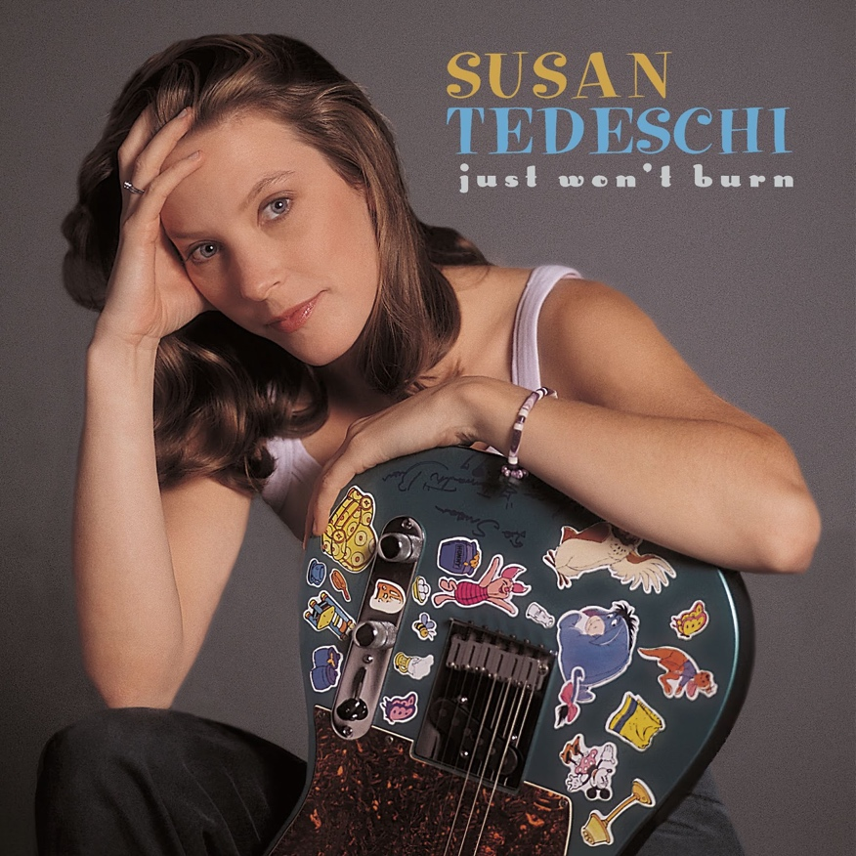
Album Art - Hi-Res Download

16-TRACK SPECIAL EDITION INCLUDES PREVIOUSLY UNRELEASED BONUS MATERIAL AND LIVE VERSIONS

FOR IMMEDIATE RELEASE - July 28, 2023 - Susan Tedeschi is one of the most celebrated blues and American roots musicians of her generation, and her unyielding commitment to her craft – both as a solo artist and in Tedeschi Trucks Band – has earned her multiple GRAMMY nominations and the adoration of audiences around the world. It all began humbly at blues jams in her native Boston back in the early ‘90s and led to significant regional acclaim, but with the 1998 release of her solo debut, Just Won’t Burn, Tedeschi put the wider music world on notice that she was a true force to be reckoned with.

In celebration of the album’s 25th anniversary, Fantasy Records will release Just Won’t Burn (25th Anniversary Edition) on September 22, 2023. This special, 16-track expanded edition features the original album plus five previously unreleased bonus tracks: an alternate take of “Looking For Answers,” two new album outtakes, and two live versions of Just Won’t Burn album tracks recorded with Tedeschi Trucks Band at NYC’s Beacon Theatre.
Pre-order various formats of Just Won’t Burn (25th Anniversary Edition) HERE. Watch the visualizer for Tedeschi’s blistering version of Koko Taylor’s “Voodoo Woman” HERE.


Photo credit: Jeff Bender Hi-Res Download

“Making Just Won’t Burn was a pivot,” Tedeschi says of the album, which was co-produced by Tom Hambridge and Tedeschi and recorded by Sean Carberry at Rear Window Studio,
Brookline, MA. The album features musicians such as guitarists Adrienne Hayes and Sean Costello and harmonica player Annie Raines tackling Tedeschi’s original songs in tandem with material popularized by Ruth Brown, Junior Wells, and John Prine. “All of a sudden, I was working with different groups of people, new musicians, new songwriting collaborators. We had no idea how it was going to turn out. I think the thing that held it all together was the blues. Blues is a language that I love. You can take it anywhere in the world and communicate with people, which isn’t necessarily true about other forms of music. And being a white artist in a black milieu, you just have to let the music speak.”

Speak it did, as Just Won’t Burn went Platinum (a rare achievement for a blues-based album at that time) and earned Tedeschi a GRAMMY nomination for Best New Artist in 2000 (alongside the of-the-moment cast of Britney Spears, Macy Gray, Kid Rock, and Christina Aguilera).
It would be the first of five GRAMMY nominations for Tedeschi as a solo artist, with each of her next three solo releases earning nods for Best Contemporary Blues Album.

Even after 25 years, the past-decade plus of which have seen Tedeschi rise to even greater heights with her husband Derek Trucks in Tedeschi Trucks Band, Just Won’t Burn remains a touchstone of blues-based rock’n’roll. “The way people react to Just Won’t Burn has always been heartwarming and surprising,” she admits. “I used to get letters from a prisoner who identified with the songs and found hope in them, and then I started getting letters from the rest of the prisoners on the cell block because it was the only cassette they had.”

“Sometimes when I look back on the 25 years since the release, I think about the places I’ve been and the adventures I’ve had, and I feel like Forrest Gump,” Tedeschi continues. “I say, ‘No! You’re a baseball mom. You didn’t do all that!’ But I must have. The blues has its demands. You have to be honest — musically, emotionally, and personally — above everything else, and that can lead to some uncomfortable truths. But the blues hasn’t burned me. It hasn’t hurt me. It’s
my main resource. I can express myself and get stuff out about my life – or, like B.B. always said, ‘whatever ails you.’ The blues got me here.”

Just Won’t Burn (25th Anniversary Edition) Track List:
​​1. Rock Me Right
2. You Need to Be With Me
3. Little By Little
4. It Hurt So Bad
5. Found Someone New
6. Looking For Answers
7. Can’t Leave You Alone
8. Just Won’t Burn
9. Mama, He Treats Your Daughter Mean
10. Angel From Montgomery
11. Friar’s Point

BONUS TRACKS
12. Looking For Answers (Alternate Take)
13. Voodoo Woman (Album Outtake)
14. Waste Of Time (Album Outtake)
15. Looking For Answers (Tedeschi Trucks Band - Live at the Beacon
Theatre,10/06/2022)
16. Just Won’t Burn (Tedeschi Trucks Band - Live at the Beacon Theatre,
10/07/2022)

FOLLOW SUSAN TEDESCHI
Website | TikTok | Instagram | Facebook | YouTube
Fantasy Records

For more information, contact:
Meg Helsel @ Grandstand Media Meghanh@grandstandhq.com
Dana Erickson @ Grandstand Media Danae@grandstandhq.com
Jessica Puchli @ Grandstand Media jessicap@grandstandhq.com
or
Joel Amsterdam @ Fantasy Records joel@fantasyrecordings.com

