

DEVON GILFILLIAN DEBUTS NEW SINGLE
"RIGHT KIND OF CRAZY"

NEW ALBUM, LOVE YOU ANYWAY OUT APRIL 7
VIA FANTASY RECORDS

WATCH THE VIDEO FOR “Right Kind of Crazy” HERE

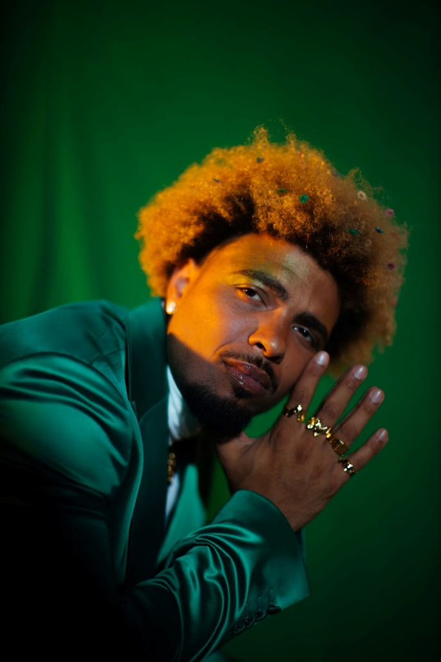
Photo Credit: Emmanuel Afolabi Hi-Res Download

ON TOUR THIS SPRING

FOR IMMEDIATE RELEASE - March 24, 2023 - Today, rising soul artist Devon Gilfillian shares "Right Kind of Crazy," a brand new track from his upcoming full-length studio album, Love You Anyway, which is set for release April 7, 2023, via Fantasy Records. The new single, a delectable slice of hip-hop inflected R&B, comes on the heels of Devon’s impressive week at the SXSW Music Festival in Austin, where he performed stellar sets at Willie Nelson’s annual Luck Reunion, as well as showcases for Waterloo Records, Paste Magazine, Relix Magazine, Jam in the Van, and many more.

Watch the “Right Kind of Crazy” video HERE and pre-order Love You Anyway HERE.

“Love can be chaotic and beautiful and so often in the early stages of romance almost intoxicating,” Devon explains. “‘Right Kind of Crazy’ is a song about what comes next, the deeper understanding a couple can reach as they start to truly see each other through that chaos. There’s a beauty in that, a real power in truly knowing someone and still allowing for that intoxication to creep in, when the lights are low, and the right song is on…”

Last month, Devon premiered the album’s first single, the alluring Temptations infused gem “All I Really Wanna Do,” that The Philadelphia Inquirer called “an irresistible slinky and soulful candy-colored invitation.” This week, the track debuts Top 25 on the Mediabase Triple A Chart, hits Top 20 on Billboard’s Adult Alternative Chart and was added to Sirius XM’s Spectrum Channel. Meanwhile, the album Love You Anyway is a Top 15 entry on the Non-Comm Albums chart.

Next month, Devon heads out on tour for shows throughout the spring and summer including his first-ever performance at Tennessee's famed Bonnaroo Music & Arts Festival on June 17 and the recently announced Oceans Calling Festival in Maryland on September 29. To celebrate the release of Love You Anyway, Devon will headline the Mercury Lounge in NYC on April 17, and is scheduled to perform at Nashville’s legendary Ryman Auditorium supporting Emily King on May 26.

Gilfillian’s Love You Anyway spans soul, hip-hop, R&B, and rock, all under the banner of Black joy. Produced by Jeremy Lutito (Joy Oladokun, NEEDTOBREATHE), the album confronts as well as comforts, chronicling Gilfillian’s journey as a Black artist living in 21st century America. The LP’s 10 original tracks (all co-written by Gilfillian), are as much about fighting for what you believe in: equity and representation, as they are about love: finding it, making it, and channeling it into every facet of our lives.

Growing up in Philadelphia, Gilfillian discovered that the towering icons of his musician father’s era—Ray Charles, Stevie Wonder, Otis Redding, The Temptations—were just as formative and exciting as the new sounds of his own generation: Wu-Tang Clan, Notorious B.I.G., and Jay-Z. Bursting on the scene in 2020 with his highly regarded debut album Black Hole Rainbow, Devon received acclaim from NPR, the New York Times, PASTE and The Tennessean, among many others. Then later that year, Gilfillian re-recorded and released Marvin Gaye’s iconic album, What’s Going On, which raised funds for low-income communities of color, and provided resources and education around the democratic process.

Now, with Love You Anyway, Devon Gilfillian pays it forward. Conjuring the raw, sexy emotions of his predecessors and the next-level production grooves of his R&B and hip-hop contemporaries, Gilfillian is taking soul music into an exciting and restorative new future.

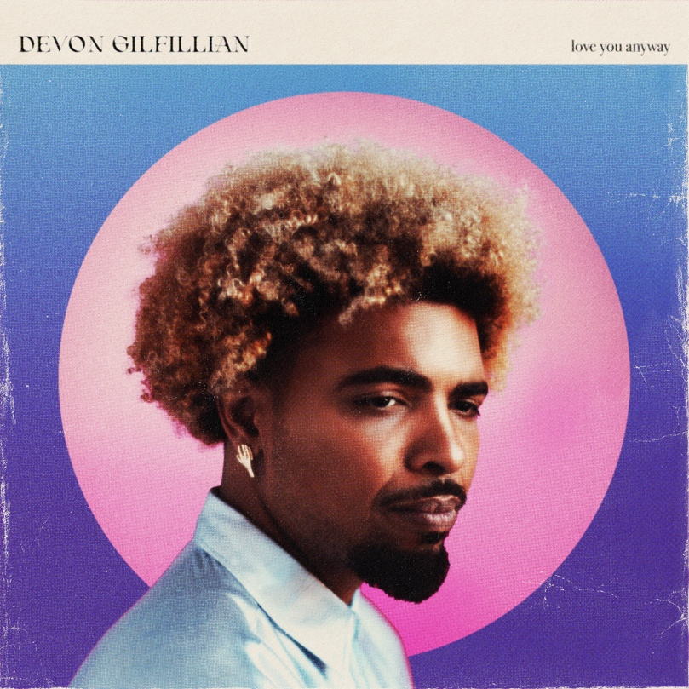
Album Art - Hi-Res Download

Devon Gilfillian - Love You Anyway TRACK LIST:
1. All I Really Wanna Do
2. The Recipe
3. Brown Sugar Queen (feat. Janice)
4. Right Kind Of Crazy
5. Let The Water Flow
6. Imma Let My Body Move
7. Better Broken
8. Follow The Leader
9. Righteous (feat. Nathaniel Rateliff)
10. Piano (Interlude)
11. Love You Anyway

Devon Gilfillian On Tour:
APR 12 - Nashville, TN - Grimey’s New & Preloved Music
APR 14 - Philadelphia, PA - Main Street Music
APR 17 - New York, NY - Mercury Lounge (album release show)
APR 22 - Carrboro, NC - Cat’s Cradle
APR 23 - Charlotte, NC - Tuck Fest
MAY 26 - Nashville, TN - Ryman Auditorium *Supporting Emily King
JUN 9 - Selbyville, DE - Freeman Arts Pavilion
JUN 10 - Boston, MA - Leader Bank Pavilion
JUN 11 - Gilford, NH - Bank of New Hampshire Pavilion
JUN 17 - Manchester, TN - Bonnaroo
SEP 15 - Shelburne, VT - Shelbourne Museum *Supporting Grace Potter
SEP 16 - Shelburne, VT - Shelbourne Museum
SEP 29 - Ocean City, MD - Oceans Calling Festival

Connect with Devon Gilfillian:
Website | TikTok | Instagram | Facebook | Twitter | Spotify | Apple | YouTube

Contact:
Shore Fire Media
Allison Elbl aelbl@shorefire.com
Cory Councill ccouncill@shorefire.com

Fantasy Records
Joel Amsterdam joel@fantasyrecordings.com

