

FOR TAKING BACK SUNDAY, THE COUNTDOWN TO 152 HAS BEGUN

BELOVED ROCK BAND SHARES “KEEP GOING”
Final Preview Track From Their Highly-Anticipated New Album 152,
Due This Friday, October 27 Via Fantasy - LISTEN HERE

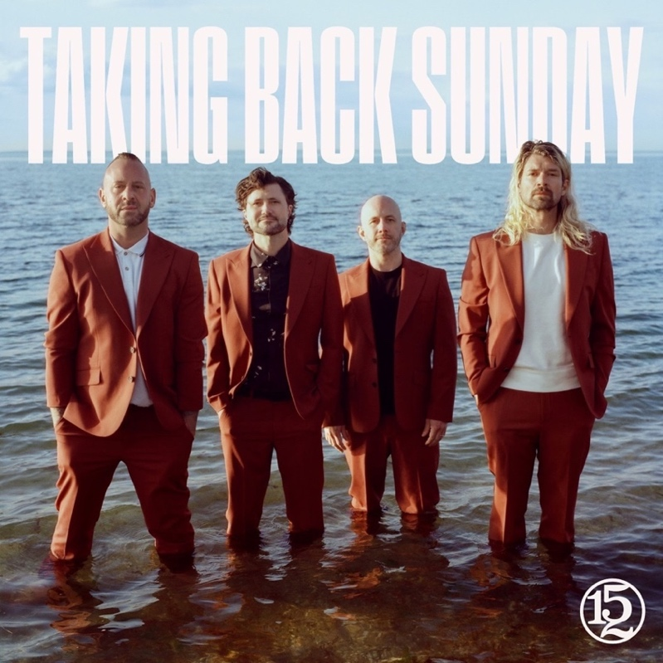
Album Cover Art - Hi-Res Download - Photo credit: Djay Brawner

Band To Host Early Album Listening Party Today
@ 4PM PT/7PM ET/12AM UK Followed By Live Video Chat

FOR IMMEDIATE RELEASE – October 25, 2023 - Today, Taking Back Sunday: John Nolan (lead guitar, piano, vocals), Adam Lazzara (lead vocals), Shaun Cooper (bass) and Mark O’Connell (drums) shared “Keep Going,” the fourth and final preview track from their upcoming new album 152, due Friday, October 27, 2023, via Fantasy. Reflecting the darkness in betrayal and the light of forgiveness, the percussive, quick-hitting rocker arrives just days ahead of the band’s long-awaited LP 152, Taking Back Sunday’s first full-length album in seven years. Listen to “Keep Going,” HERE, watch the visualizer HERE, and pre-order 152, HERE.

Mark O’Connell on “Keep Going”:
“’Keep Going’ is a song about struggling through relationships with the people you love. When it rains it pours, but you’ve got to get up and keep going. It’s a heavy song with an important message that fits the inclusive positivity of 152.”

Tonight at 4pm PT/7pm ET/12am UK, fans around the world can get a sneak peek of 152 as Taking Back Sunday hosts an album listening party followed by a live video chat with the band immediately following the playback. Find it HERE.

In addition, Taking Back Sunday will celebrate the release of 152, with series of intimate album release shows, promotional events, and in-store appearances, all of which sold-out in a matter of minutes including: Fingerprints in-Store (Long Beach, CA) November 4, Lodge Room album release show (Los Angeles) November 6, Grimey’s in-Store (Nashville) Nov. 8, Eastside Bowl album release show (Nashville) Nov 9, Looney Tunes in-store (New York) Nov. 12, and Bowery Ballroom album release show (NYC) Nov 13.

The band also recently announced the 9th Annual Taking Back Sunday Holiday Spectacular at Mulcahy’s Pub and Concert Hall in Wantagh, NY December 13 and 14, and Starland Ballroom in Sayreville, NJ on December 15 and 16. Tickets are on sale now. For more information, visit: www.takingbacksunday.com. Look for exciting 2024 tour news to be announced soon.

Produced by Tushar Apte (whom the band met through a mutual collaboration with noted DJ Steve Aoki) and mixed by Neal Avron (Twenty One Pilots, Bleachers), 152 features 10 intensely vulnerable and absorbing new tracks all delivered with fresh ambition and newfound purpose. Inspired by the long layoff and the cloud of uncertainty that blanketed the world (and music industry) these past few years, 152 stands among the most genuinely reflective and emotionally pure efforts of Taking Back Sunday’s illustrious career.

Anticipation among fans for the new album continues to build. Previously released tracks, (along with “Keep Going”) include "The One," "S'old," and "Amphetamine Smiles". All through 152, the consistent thread is one of generosity, gratitude and ultimately, hope.

152 TRACK LISTING:
"Amphetamine Smiles"
"S'old"
"The One"
"Keep Going"
"I Am the Only One Who Knows You"
"Quit Trying"
"Lightbringer"
"New Music Friday"
"Juice 2 Me"
"The Stranger"

TAKING BACK SUNDAY LIVE:
11/6 — Los Angeles, CA – Lodge Room (Album Release Show)
11/9 — Nashville, TN – Eastside Bowl (Album Release Show)
11/13 – New York, NY – Bowery Ballroom (Album Release Show)
11/29 – Melbourne, Australia – 170 Russell
12/1 — Melbourne, Australia — Good Things Festival 2023
12/2 — Sydney, Australia — Good Things Festival 2023
12/3 — Brisbane, Australia — Good Things Festival 2023
12/5 – Woolloongabba, Australia – The Princess Theatre
12/6 – Marrickville, Australia – Factory Theatre
12/13 – Wantagh, NY – Mulcahy’s Pub and Concert Hall (Holiday Spectacular)
12/14 – Wantagh, NY – Mulcahy’s Pub and Concert Hall (Holiday Spectacular)
12/15 – Sayreville, NJ – Starland Ballroom (Holiday Spectacular)
12/16 – Sayreville, NJ – Starland Ballroom (Holiday Spectacular)

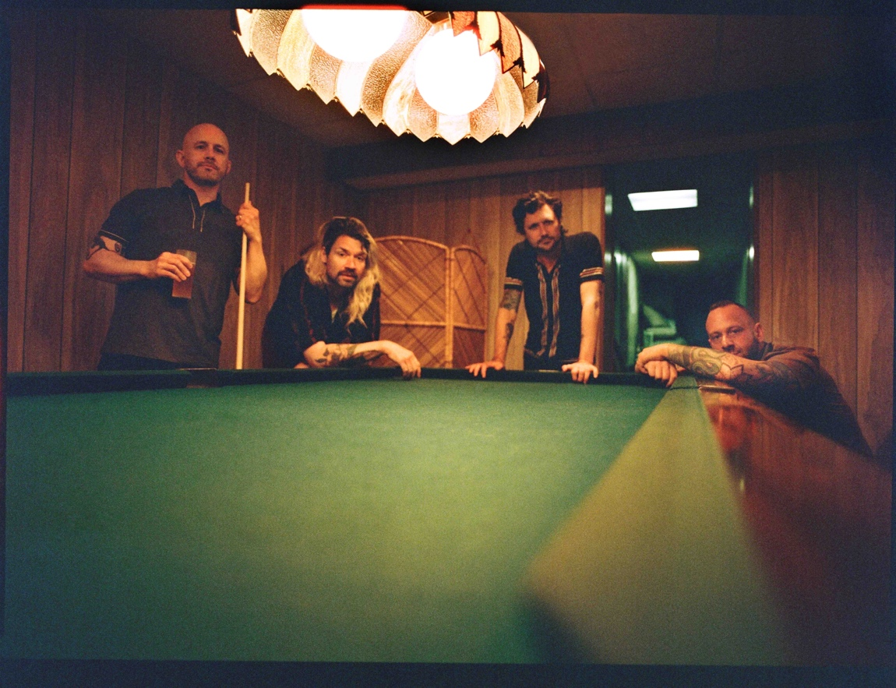
Photo credit: Djay Brawner Hi-Res Download

FOLLOW TAKING BACK SUNDAY:
Website
TikTok
Instagram
YouTube
Facebook
Twitter

Fantasy Records

For more information, please contact:
Atom Splitter PR:
Amy Sciaretto — amy@atomsplitterpr.com
Tim Tatulli — tim@atomspllitterpr.com
Fantasy Records:
Joel Amsterdam - joel@fantasyrecordings.com

