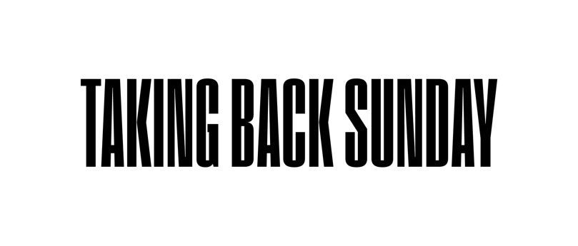
152 BIO

John Nolan (lead guitar, piano, vocals)
Adam Lazzara (lead vocals)
Shaun Cooper (bass)
Mark O’Connell (drums)

They’ve been making music together as a band for more than 20 years, have sold millions of albums—and along the way, amassed a devoted, international fan base. But ask the members of Taking Back Sunday if they still feel a burning desire to make a powerful impact and connect in a big way, and there’s not a moment of hesitation in the response. “I’m gonna try and conquer the world every time,” says lead singer Adam Lazzara with a smile.” Adds drummer Mark O’Connell: ”When we’re writing songs, the one thing we ask ourselves is, ‘will it make people feel something?’ You try to make people feel emotion. That’s the one goal we went in with, and I think we did it.”

This unrelenting pursuit of greatness lies at the heart of 152, Taking Back Sunday’s long-awaited, thrilling eighth studio album (and Fantasy Records debut) out October 27, 2023. Written and refined over the course of several years, the group’s first full-length offering since 2016’s Tidal Wave is a passionate, melody-infused confessional from a band forever known for its honesty and vulnerability. The 10-track LP was produced by Tushar Apte (whom the band met through a mutual collaboration with DJ Steve Aoki) and mixed by Neal Avron (Twenty One Pilots, Bleachers).

“What Mark describes was the process for “Amphetamine Smiles,” notes lead guitarist John Nolan. “When I brought that demo in, the band was vocal about making changes but not from some negative motivation. You have to be able to trust and listen to try to make the song better. We all had to do that constantly throughout the process of making this album, and it shows.”
“I genuinely feel we’re the band that hasn’t stopped and keeps getting better,” says Lazzara proudly of Taking Back Sunday’s unwavering creative spark. Adds bassist Shaun Cooper: “I really feel the sky’s the limit!”

When Taking Back Sunday first sat down together in late 2019 to begin working in earnest on what became 152, the band laid out some ground rules from the outset. They weren’t out to simply add more songs to their already-storied catalog, but rather make a piece of art they could be proud of. “We sat down and said, “Look, nothing mediocre is gonna stay,” recalls Lazzara. “So if you have a mediocre idea, keep simmering on it.”

To that end, so many of the songs that comprise 152 were workshopped like never before. As the band members explain, over the years they’ve learned to love letting a piece of music develop from its initial idea all the way to its sometimes drastically-different finished form. It’s a journey
they’ve undoubtebly been on many times before when making previous albums, but as they found out when making 152, it’s one that continues to thrill them and keep things fresh.

Lazzara gets animated as he describes how so many songs on 152 morphed over the multi-year writing and recording process. Whether it was “S’old” transforming from a punky, Green Day-style rocker into a slow-building, emotion-dripping plea for acceptance, or “I Am The Only One Who Knows You,” which evolved from a galloping rock song into a beatific ballad, so many of the songs that comprise 152 found Taking Back Sunday continually surprising one another with musical ideas in new and exciting ways.

“You would think after 20 years we know what each other is going to do,” offers Lazzara. “But there were so many times making this record where you would hear the initial idea and think, ‘I know where this is going,’ but then was super surprised where it ended up. It’s those kinds of surprises that make it so exciting. That’s why we all still want it so badly.” Adds Cooper: “If you can predict what each other is going to do, then it just becomes a job. It’s not an artistic expression. You’re not trying to grow.”

A major part of that growth is heard explicitly in 152’s unguarded lyrics: 20-plus years into Taking Back Sunday, Lazzara and Nolan are peeling back the curtain like never before. From the heartfelt recollections of the album’s epic opener “Amphetamine Smiles,” (We talked until the sun came up/It meant so much/we can’t remember what/You better save yourself before you try and save somebody else”), to the expressive yearning in lead single “The One” (“You were the one/Put me at ease/Brought out my best/I let you in/You ignored the mess/You didn’t mind”), listeners are invited into the songwriter’s collective heart.

“It’s often hard to turn off those other voices in your head: ‘OK, we gotta do what people expect. This is our lane,’ explains Lazzara. “I have to step out of that skin. We learned with Tidal Wave that if it’s the four of us playing it’s going to sound like Taking Back Sunday. Once we really embraced that sentiment, the world was our oyster. We were freed up to take chances.”

On the subject of the band’s renowned live performances, O’Connell didn’t mince words. “There’s no question, when it comes to the stage, no one is getting left behind,” he declared. “No one wants to be the weak link. We all want to step up our game up because we love it. The amount of effort we give on stage is crazy, especially with Nathan Cogan Post, who performs with us on the road. He’s a very big part of that effort as well. When you get a little older, you don’t want to waste time, time is what we got, so let’s make the most of it.”

When it came time to title the project, 152 was the only option. A section of road in North Carolina between Highpoint, Chapel Hill and Raleigh where the band and their friends would meet up as teenagers before seeing shows, 152 has become synomynous with Taking Back Sunday and has appeared in some form on every one of their album covers.

“We wanted something that represents us as a band and who we are now,” says Cooper of the title. “The universe was pointing us in that direction. This is what we have to do.” Adds Lazzara, “It was right there waiting for us. It was a nod to all our friends and our people.”

Revitalized and unusually optimistic, Taking Back Sunday is ready to embrace what lies ahead. “Normally it’s like, this is working right now, let’s just go with it and see what happens,” admits Lazzara. “But the process of making this record has helped get me to a point where I’m looking ahead. I’m so excited about the possibilities. You’ve got to keep moving forward. We need to continue building onto this wonderful world.”

